Stage 1 – "Dead or alive you’re coming with me"
COURSE DESIGNER: Ike Starnes (Blue Team Shooting Sports)
SCORING: Comstock 24 rounds.
TARGETS: 12 cardboard targets.
SCORED HITS: 2 Best hits per carboard will be scored.

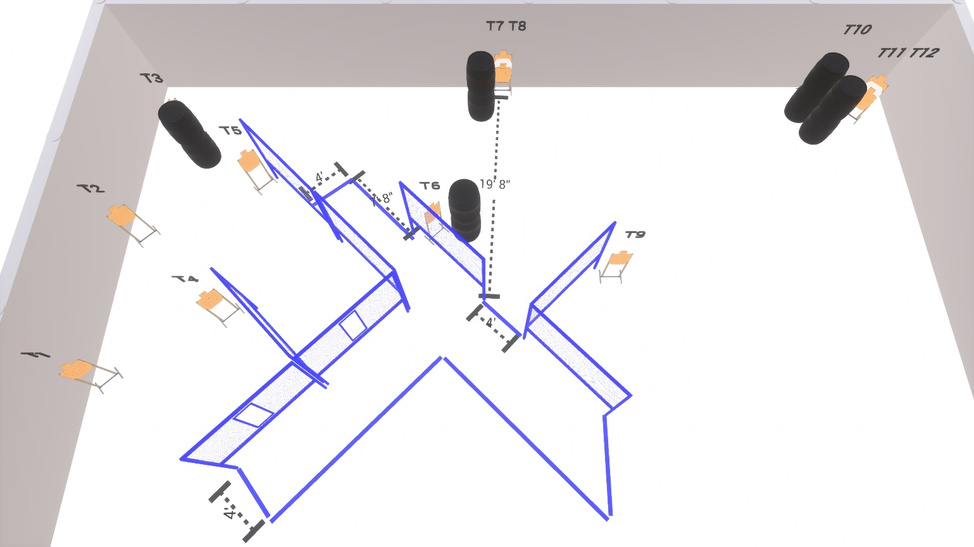

Written Stage Briefing:

Stage 1 – "Dead or alive you’re coming with me" - is a 24 round, 120 point, Comstock Course. There are 12 cardboard targets.

Starting with Both feet anywhere inside the shooting area.
Handgun is loaded and holstered, wrists below belt.
PCC is loaded held in both hands, stock on belt.

On the audible start signal, engage targets from within the shooting area.

USPSA / NROI Range Commands:
- Make Ready
- Are you ready?
- Standby
- If finished, unload and show clear
- If clear, hammer down and holster (Handgun)
If clear, hammer down and flag (PCC)
If clear, cylinder closed and holster (Revolver)
- Range is clear

Setup Notes:
7 Single Wall Stands
3 Double Wall Stands
1 Triple Wall Stands
6 Full Walls
2 Port Wall
12 Target stands / 24 target sticks
10+ Barrels



